Mathematical Lemma

🌟 Definition
# Source: AI Source: Provided by: [Data Path: Persons Table -> ID Column: 1, Name_En Column: Motasem Essam] -> From: [ChatGPT] on [5/29/2026]
A mathematical lemma is a proven statement used as a stepping stone to help prove a larger and more important result, usually a theorem.
A lemma is like a helper theorem.

🎯 Purpose of a Lemma
# Source: AI Source: Provided by: [Data Path: Persons Table -> ID Column: 1, Name_En Column: Motasem Essam] -> From: [ChatGPT] on [5/29/2026]
- To break complex proofs into smaller parts
- To simplify the proof of a theorem
- To organize logical steps clearly
- To provide intermediate results
- To make difficult arguments easier to manage

📚 Key Characteristics
# Source: AI Source: Provided by: [Data Path: Persons Table -> ID Column: 1, Name_En Column: Motasem Essam] -> From: [ChatGPT] on [5/29/2026]
A lemma is:
- A proven mathematical statement
- Used mainly to support a theorem
- Often less important than the final result
- Essential in long or complex proofs
- Sometimes useful on its own

🧩 Structure of a Lemma
# Source: AI Source: Provided by: [Data Path: Persons Table -> ID Column: 1, Name_En Column: Motasem Essam] -> From: [ChatGPT] on [5/29/2026]
- Statement (what is being claimed)
- Proof (logical justification)
- Application in a larger theorem

✏️ Examples of Lemmas

Example 1 (Geometry)
# Source: AI Source: Provided by: [Data Path: Persons Table -> ID Column: 1, Name_En Column: Motasem Essam] -> From: [ChatGPT] on [5/29/2026]
A lemma may show:
- A property of angles in a triangle
This is then used to prove a major theorem about triangles.

Example 2 (Number Theory)
# Source: AI Source: Provided by: [Data Path: Persons Table -> ID Column: 1, Name_En Column: Motasem Essam] -> From: [ChatGPT] on [5/29/2026]
A lemma might prove:
- A property of divisibility
Used later to prove the Fundamental Theorem of Arithmetic.

Example 3 (Symbolic Example)
# Source: AI Source: Provided by: [Data Path: Persons Table -> ID Column: 1, Name_En Column: Motasem Essam] -> From: [ChatGPT] on [5/29/2026]
$$a=b⇒a+c=b+c$$
This lemma can be used in many algebra proofs.

🔗 Relationship to Other Concepts
# Source: AI Source: Provided by: [Data Path: Persons Table -> ID Column: 1, Name_En Column: Motasem Essam] -> From: [ChatGPT] on [5/29/2026]
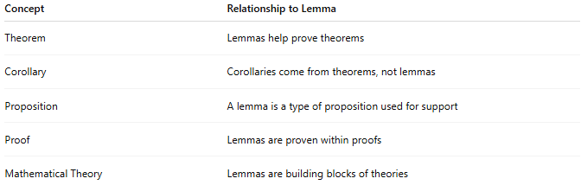
Concept | Relationship to Lemma
Theorem | Lemmas help prove theorems
Corollary | Corollaries come from theorems, not lemmas
Proposition | A lemma is a type of proposition used for support
Proof | Lemmas are proven within proofs
Mathematical Theory | Lemmas are building blocks of theories

📖 Lemma vs Theorem vs Corollary
# Source: AI Source: Provided by: [Data Path: Persons Table -> ID Column: 1, Name_En Column: Motasem Essam] -> From: [ChatGPT] on [5/29/2026]
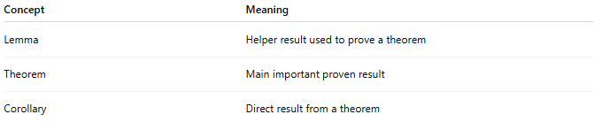
Concept | Meaning
Lemma | Helper result used to prove a theorem
Theorem | Main important proven result
Corollary | Direct result from a theorem

🧠 Simple Analogy
# Source: AI Source: Provided by: [Data Path: Persons Table -> ID Column: 1, Name_En Column: Motasem Essam] -> From: [ChatGPT] on [5/29/2026]
A lemma is like a supporting brick in a building:
- It is not the final building (the theorem)
- But without it, the building cannot stand

🧭 Summary
# Source: AI Source: Provided by: [Data Path: Persons Table -> ID Column: 1, Name_En Column: Motasem Essam] -> From: [ChatGPT] on [5/29/2026]
A mathematical lemma is a proven result used to help prove a larger theorem. It acts as an intermediate step that makes complex mathematical proofs easier and more structured.

